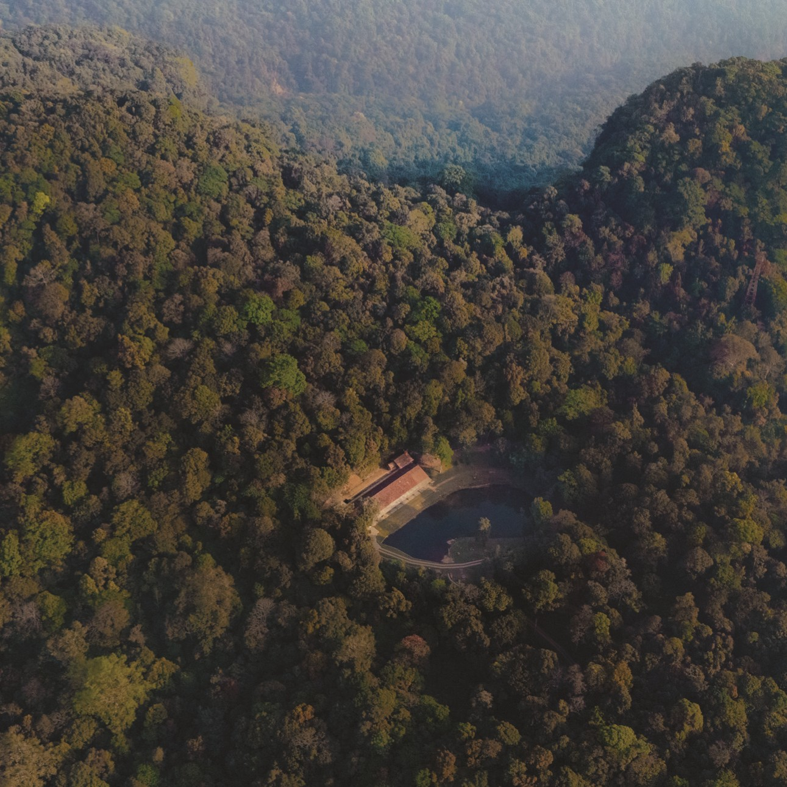

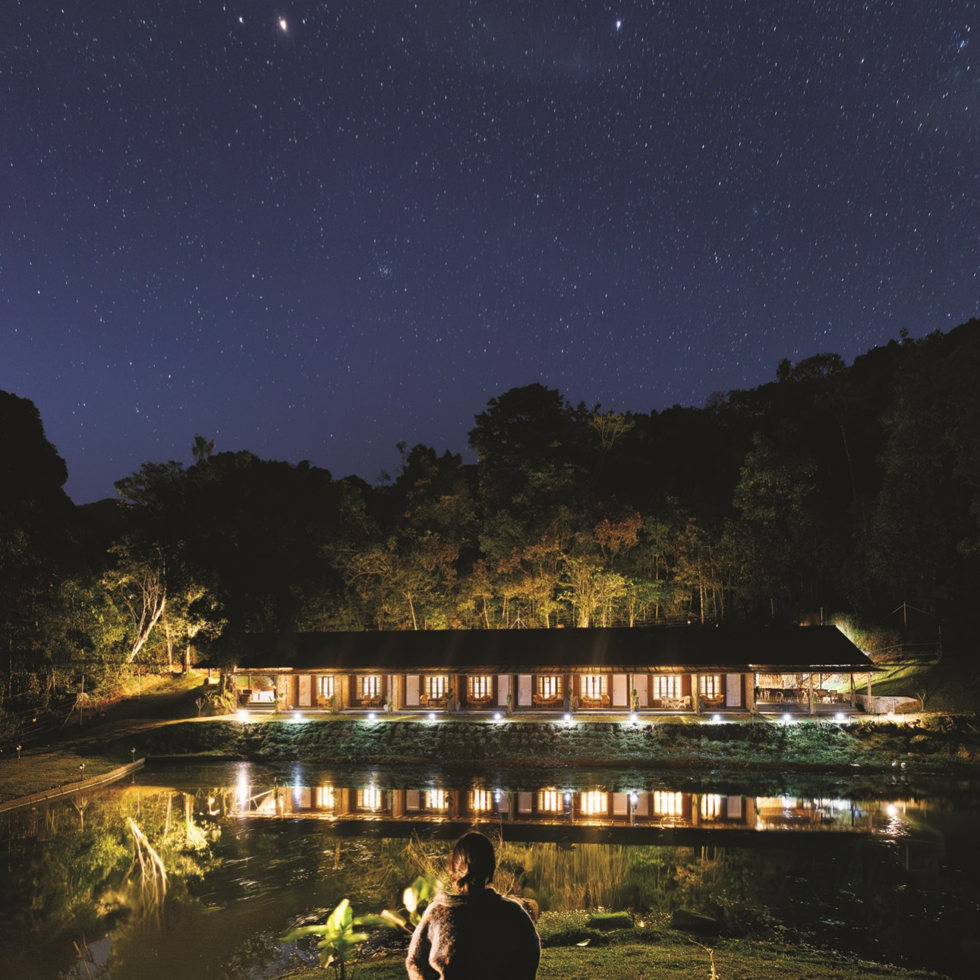




WAYANAD
Where Nature Speaks to Your Soul
Kerala was named one of the 50 extraordinary places in the world by TIME
magazine—and Wayanad proves why.
Set in the Western Ghats, one of only eight UNESCO-recognized biodiversity
hotspots in the world, Wayanad is among the most secluded and untouched
regions in India. With its cool climate, misty hills, and rainforest landscape, it
offers a rare connection to nature.
At the centre of it all lies Vythiri—Wayanad’s most scenic and peaceful corner.
And there’s one place here that brings the magic to life



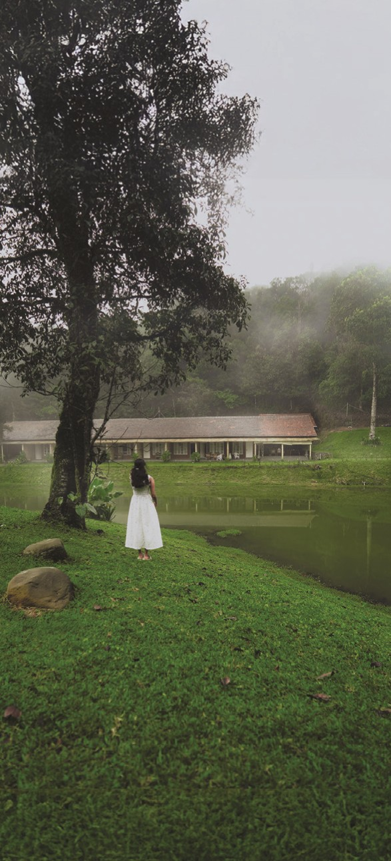







else you’ll find.
Presidential Award
Best View in India
JUNGLE PARK
Located 7 km deep inside the forest, Jungle
Park Resort by GreenEscapes is the highest
resort in Wayanad, and arguably the highest
jungle resort in the world with a sea view.
Sprawling 900 acres of lush greenery in
Wayanad, it was built in 1996 as one of the
first resorts in the region and went on to win
the Presidential Award for the Best View in
India. At 7°C cooler than the rest of
Wayanad, this luxury forest resort is quieter,
wilder, and more exclusive than anything
Watch clouds sweep across the lake from
your private balcony. Wake up to birdsong,
see black monkeys swinging through the
trees, and kayak through a mist-covered
lake right outside your room. Accessed by a
scenic forest drive, the journey itself sets the
mood for what follows.
national
by
Designed
award-winning
built
architects
and
using
sustainable
materials, Jungle Park stands as one of the
most uniquely located and thoughtfully
crafted resorts in the country.
This is a once-in-a-lifetime experience. Truly
one of India’s most magical places to stay.
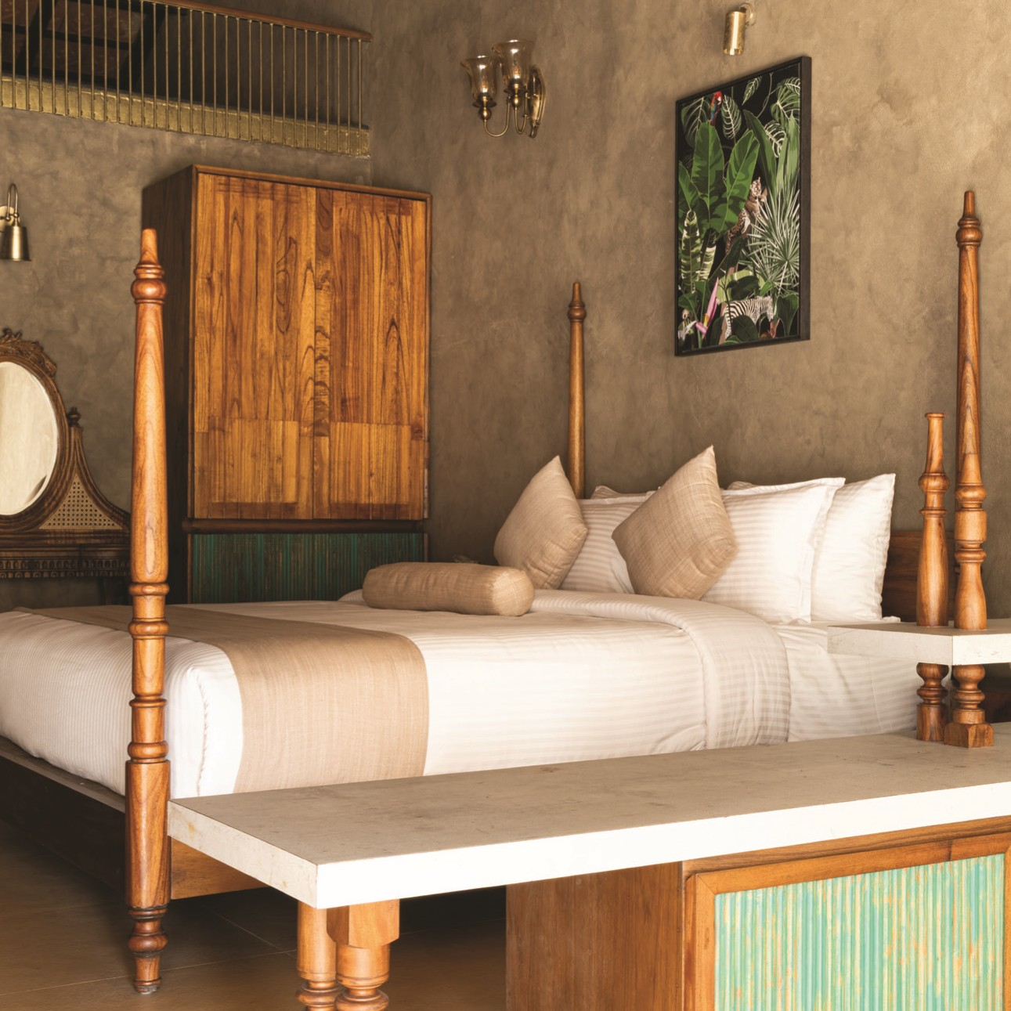
Luxury Lakeview
Duplex Suite
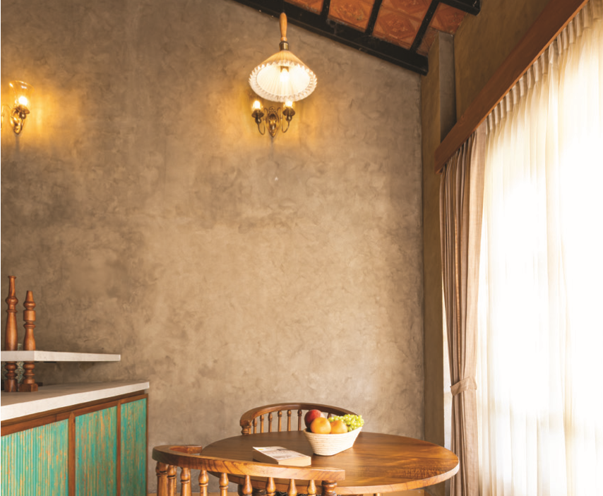
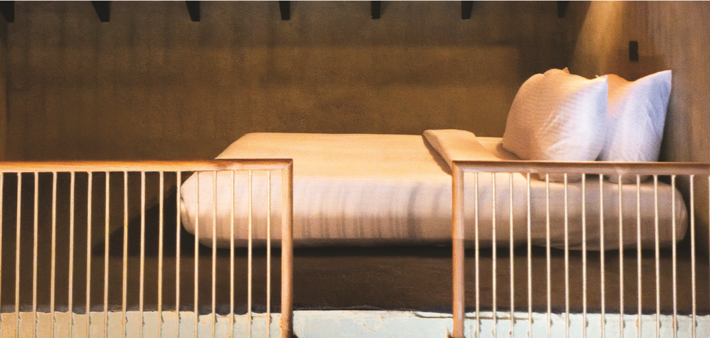
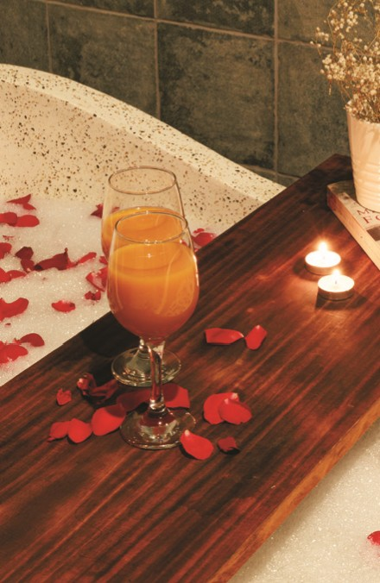
KING BED
BATH TUB
LIVING AREA
RAIN SHOWER
PATIO
Indulge in ultimate luxury and privacy with our
exclusive luxury suites. Featuring a bathtub for
a relaxing retreat, our resort is the perfect
romantic getaway for couples in Wayanad
ATTIC SPACE
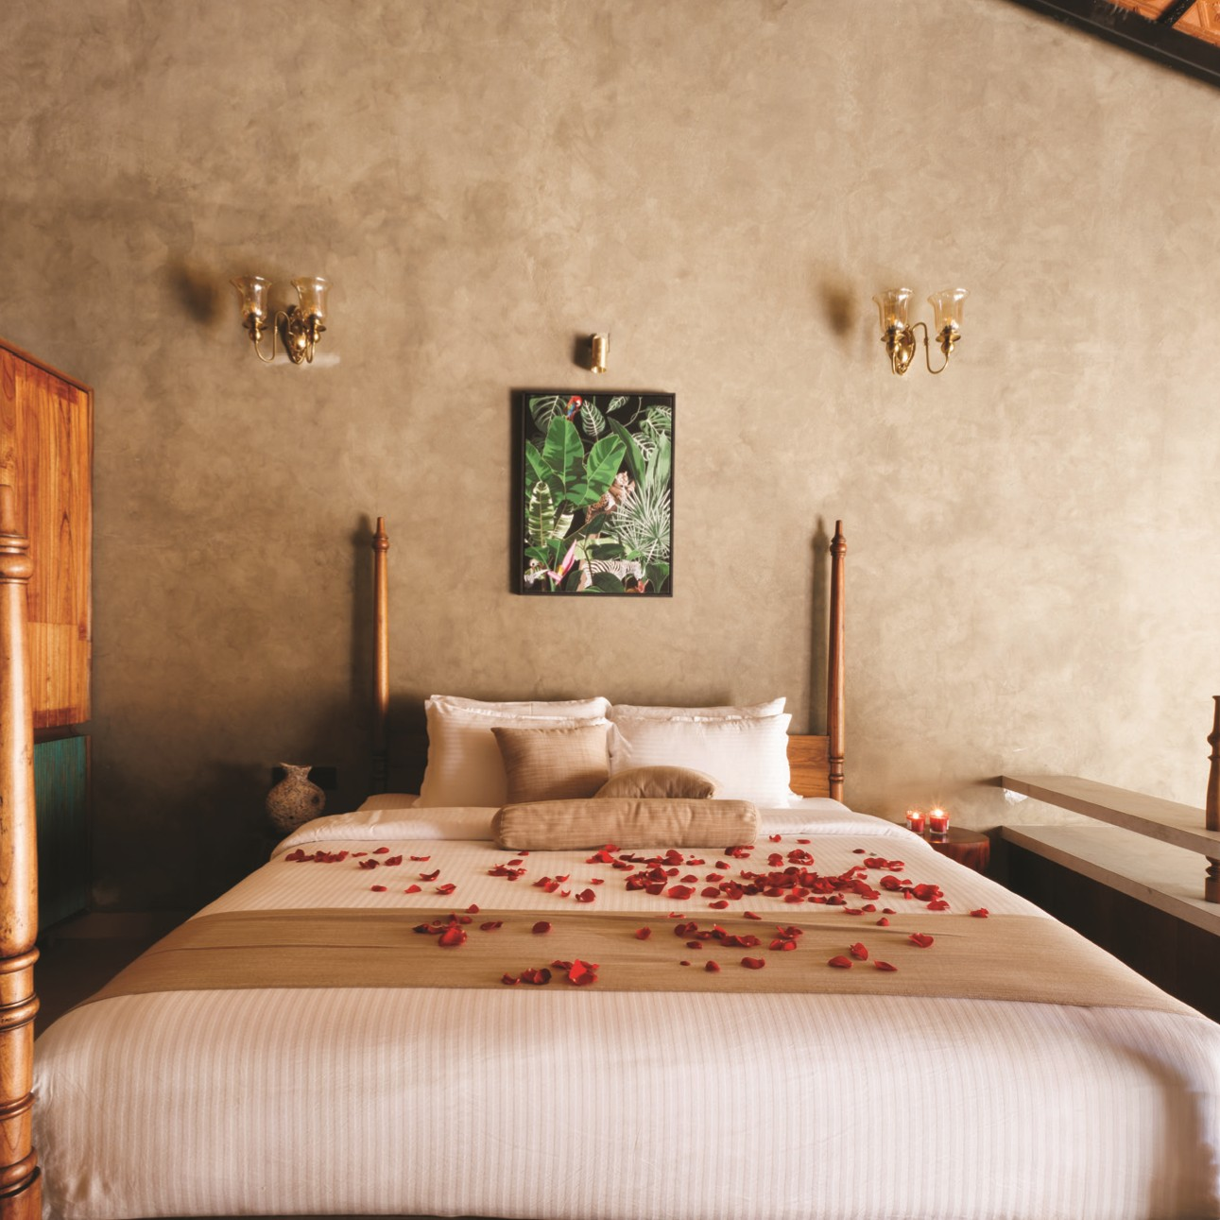
Premium Lakeview
Duplex Suite
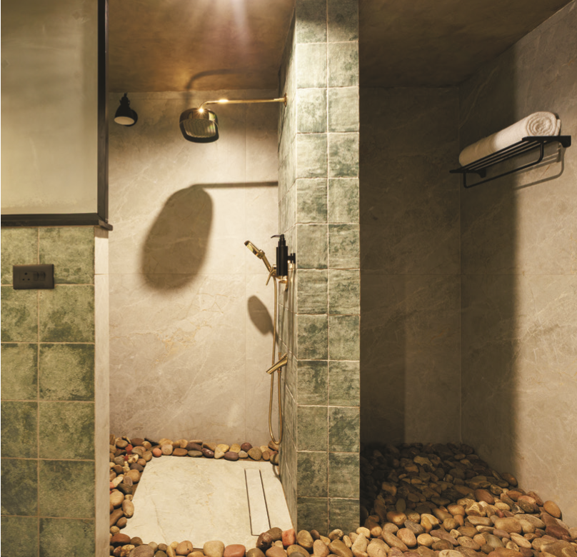
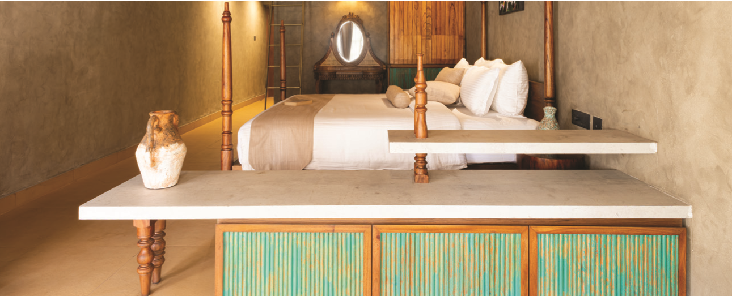
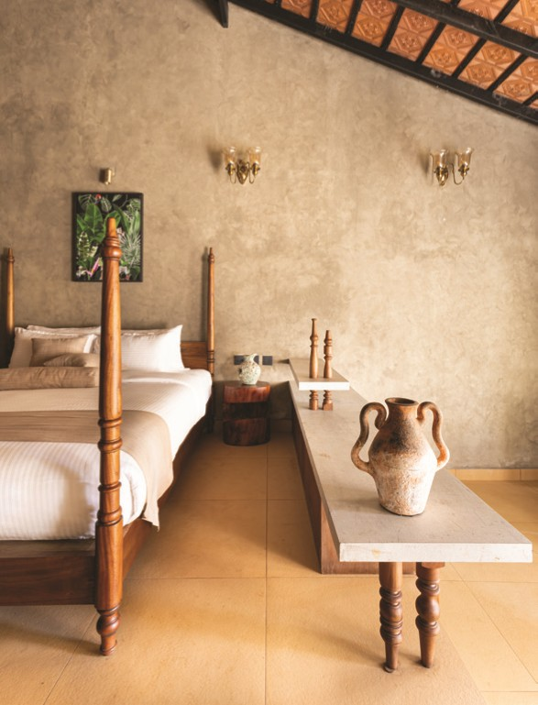
KING BED
LIVING AREA
RAIN SHOWER
ATTIC SPACE
PATIO
Indulge in ultimate luxury and privacy with our
exclusive luxury suites. Featuring a bathtub for
a relaxing retreat, our resort is the perfect
romantic getaway for couples in Wayanad
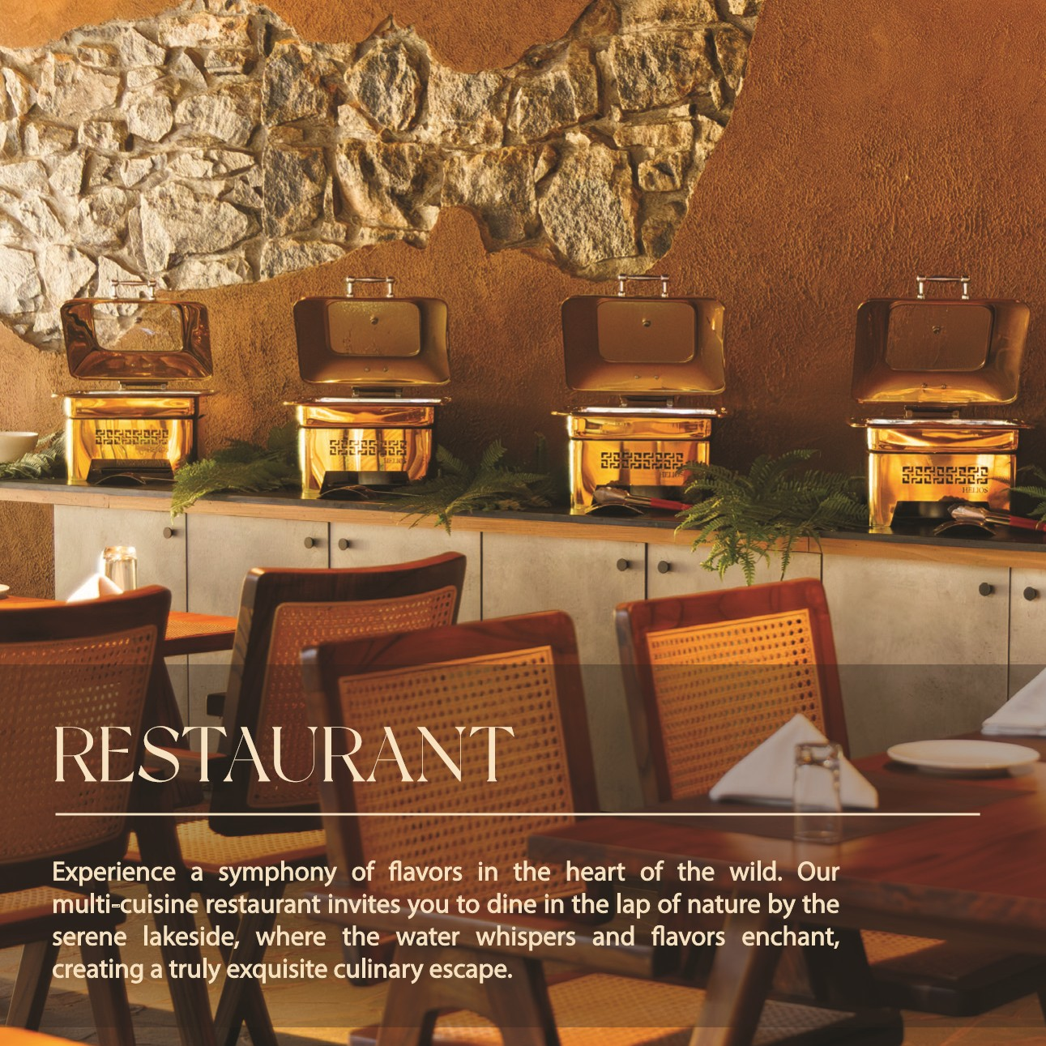
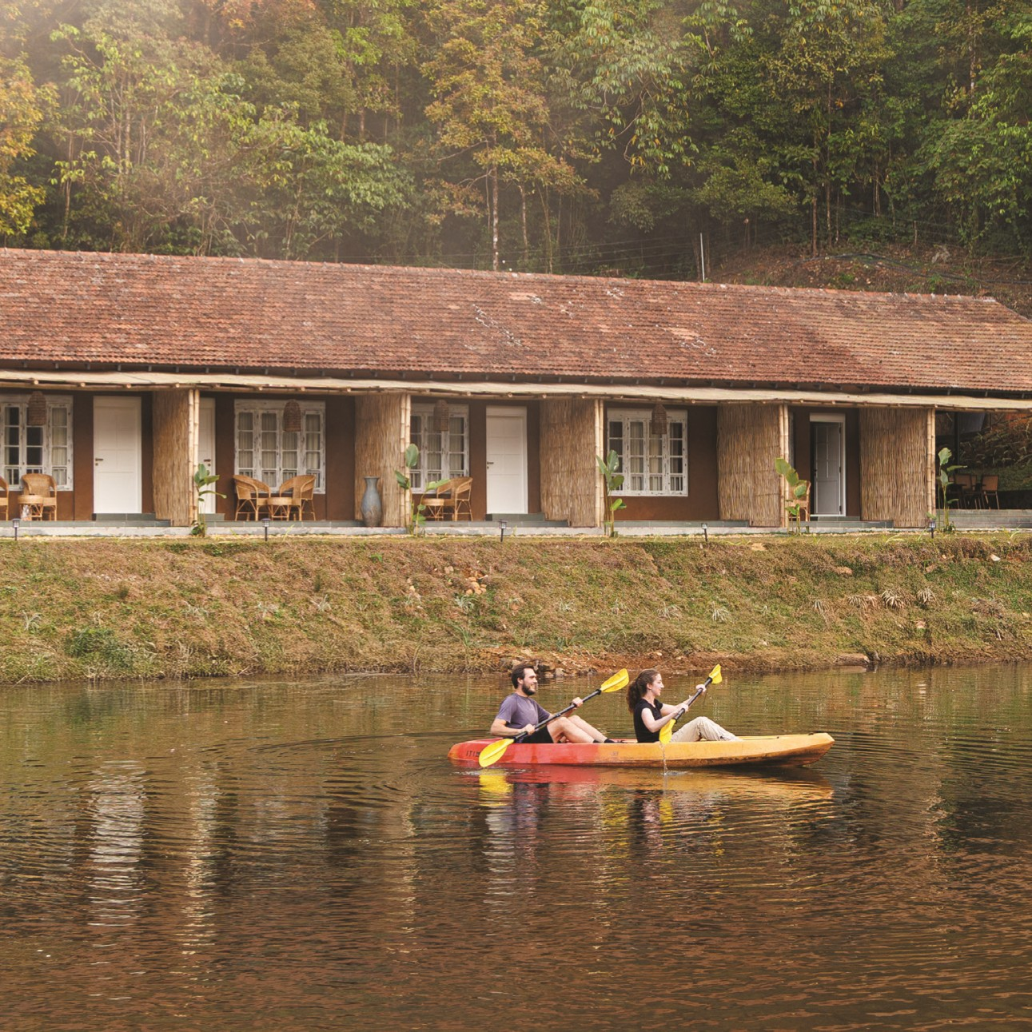
EXPERIENCE
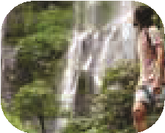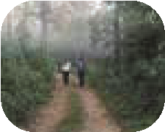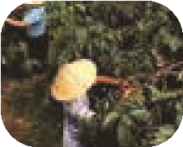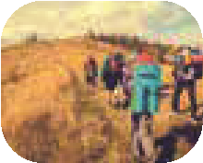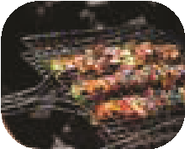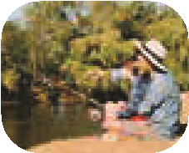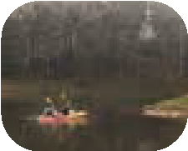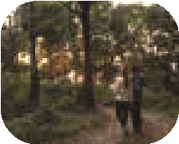
Trekking Expedition
Wildlife Safari
Barbeque
Cloud sweeping
Kayaking
Tour
Fishing Excursions
Archery, Shooting
and Football
Bird watching
Star gazing
Candle light dinner
Waterfall expedition
View point
